Instructions on How to Login & Register in ADP

First Time Users:
- Go to https://portal.adp.com
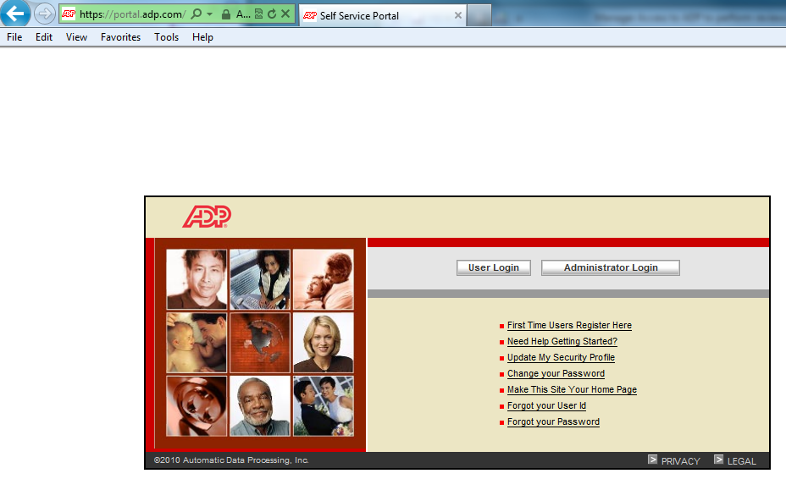
- Please select: First Time Users Register Here

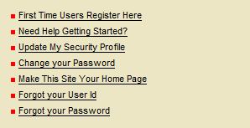

- In the Registration code field, enter: Nahospital-Nahospital, then press “next”
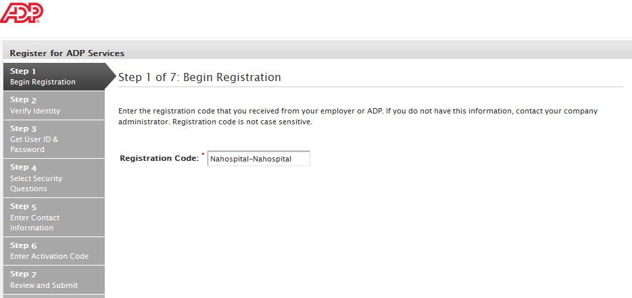
- Enter your First Name, Last Name, SSN and confirm your SSN, then press “next”
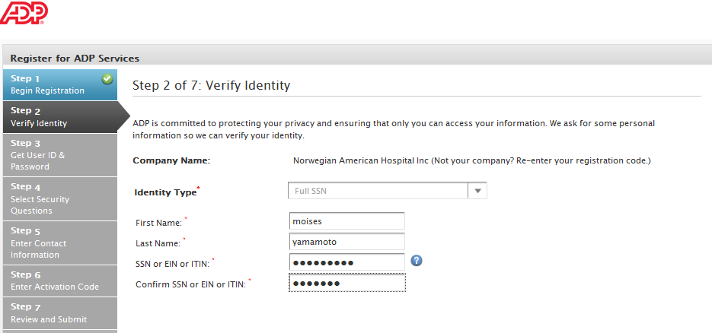
- Your username will be on the top of the screen, please enter a password and then press “next”
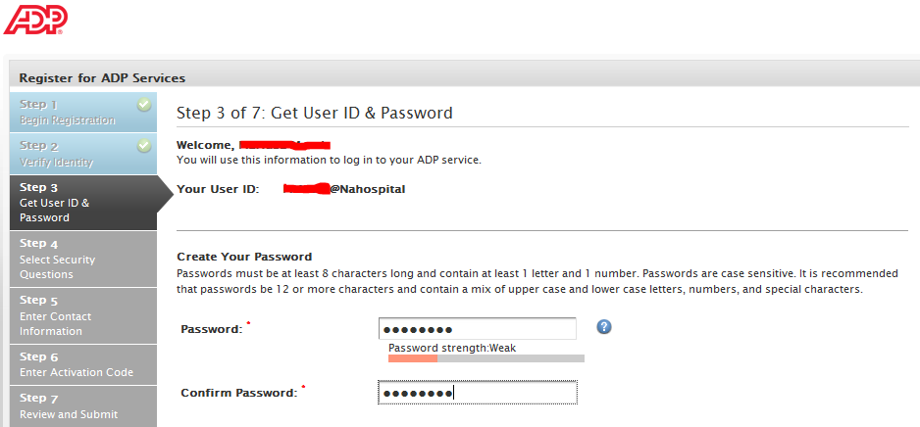
- Please select 3 security questions, type your answers and then press “next”

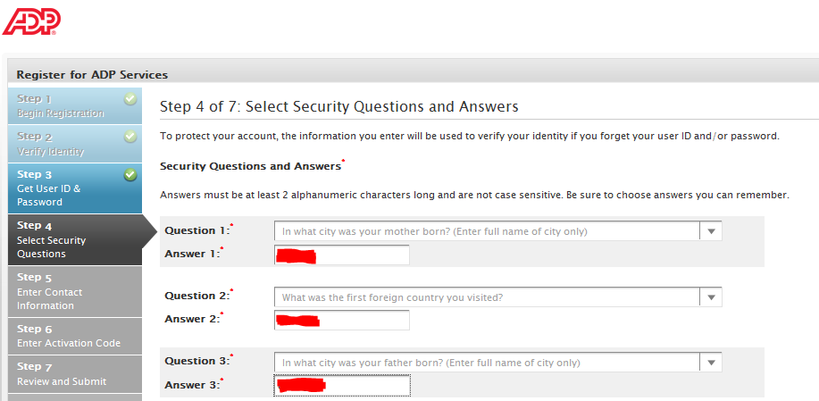
- Please verify your email for notifications and enter your work phone number, then press “next”
- ADP will send you an email with your activation code, please enter the code and then press “next”
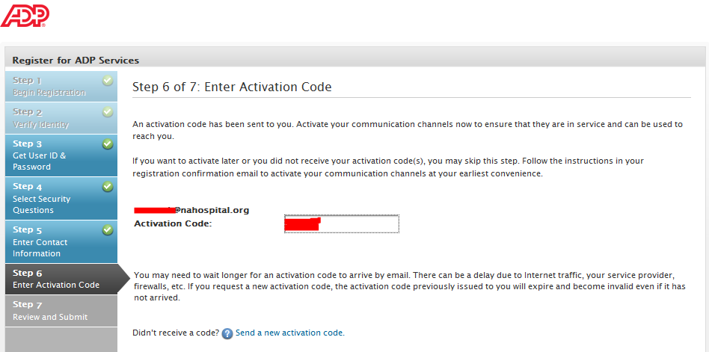
- Please review your information, if you need to make corrections select “Previous” otherwise press “Done”
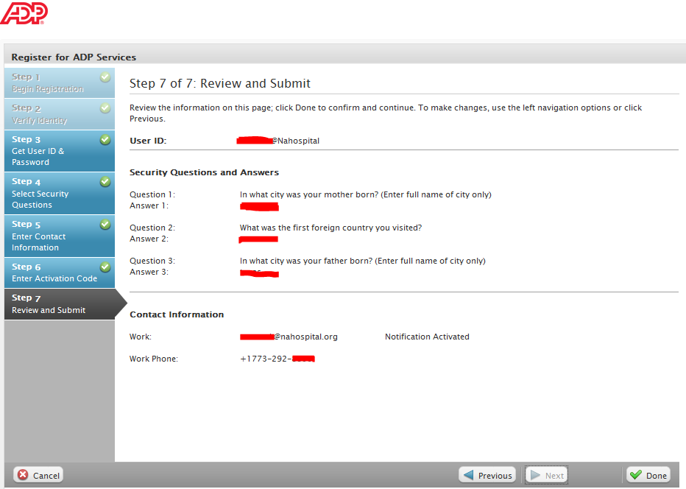
- 10. Your registration is complete, go to ADP Portal and log in

